LAB # 03

Exercise

Theory Question
- Write directory structure of web development for static web sites?

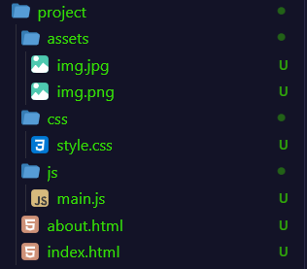
Answer:

- Define image tag with attributes with syntax.

Answer:

The <img> tag is an empty (self-closing) tag used to embed images in an HTML page.

<img src="image.jpg" alt="description" width="300" height="200" title="tooltip"> Attributes: src (path), alt (alternate text), width, height, title.

- How you can differentiate between the static and dynamic web site.

Answer:

Static | Dynamic
Fixed content | Content changes per user/request
No database | Uses database
Faster, cheaper | Slower, costlier
Only HTML/CSS/JS | Uses server-side languages (PHP, Node.js)
Example: Portfolio site | Example: Facebook, Amazon

Practical Question
- Write a HTML program same as above example-3 using by images and scrolling tags Answer:

Input

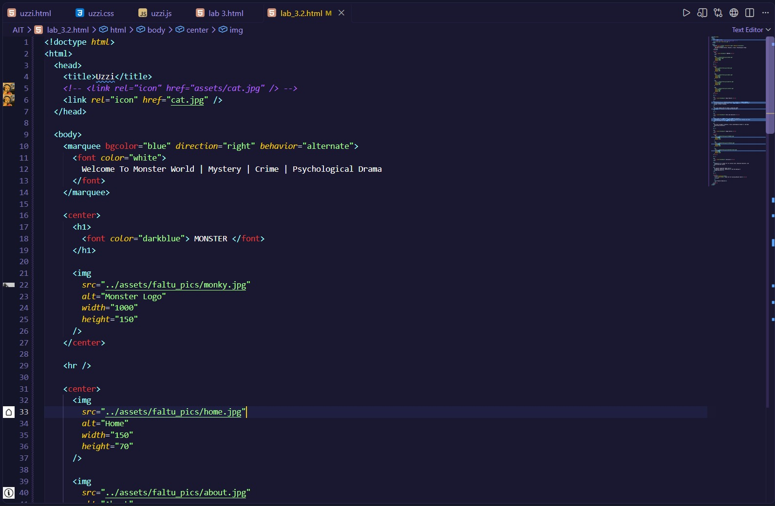

Output

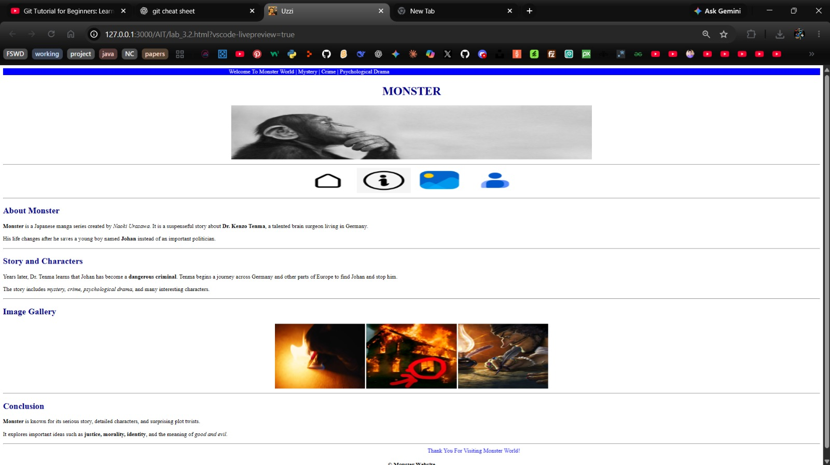

Objective and MCQ
- Which provides attributes the direction or way in which your marquee will allow you to scroll. The value of this attribute can be: left, right, up or down .
  - width
  - behavior
  - direction
  - move.

- Which attributes provides the scrolling type in a marquee. That scrolling can be like sliding, scrolling or alternate tags
  - behavior
  - direction
  - move
  - class

- Which attribute Specifies an alternate text for the image, if the image for some reason cannot be displayed.
  - width
  - height
  - alt
  - src

- Which attribute Specifies the path to the image.
  - width
  - height
  - alt
  - src

